

Higher Institute of Engineering & Technology, El-Beheira

Computer Engineering Department

First assignment in numerical analysis

Under supervision of Dr.Mahmoud Gamal

|  |  |
| --- | --- |
| Team | ID |
| Mohamed Yosry El-Zarka | 19100 |
| Youssef Mohamed El-Sheheimy | 19124 |
| Omar Abd Al-Halim Khalil | 19138 |

**Source code in python: -**

1. print('Project for "Numerical analysis". under the supervision of Dr. Mahmoud Gamal')
2. print('by:')
3. print('\t\tMohamed Yosry ElZarka 19100')
4. print('\t\tYoussef Mohamed Elsheheimy 19124')
5. print('\t\tOmar Abd Al-Halim Khalil 19138\n')
6. print("This is a program to calculate the numerical integration of a function using the trapezoidal rule.\n")
7. while True:
8. n=int( input("enter the number of dots: ") )
9. s=float( input("enter the start of the integration: ") )
10. e=float( input("enter the end of the integration: ") )
11. h=(e-s)/(n-1)
12. X=[]
13. fX=[]
14. for i in range(0,n):

X.append( float( s+h*i ) )

1. print("\nyou can use parentheses () in addition to the following mathematical operators:")
2. print("(+ Add), (- Subtract), (* Multiply), (/ Divide), (% Modulus), (// Floor division), (** Exponent)\n")
3. x = 1
4. stri=str(input("enter the equation: f(x)= "))
5. sum=0
6. for i in range(0,n):

x=X[i]

fX.append( eval(stri) )

sum+=fX[i]

1. sum= sum - 0.5*fX[0] - 0.5*fX[n-1]
2. print('\nh=',h)
3. print("x=",X)
4. print("f(x)=",fX)
5. print("")
6. print("from",s,"to",e, "   ∫ f(x) dx= ∫",stri,"dx=",sum*h)
7. print('__________________________')
8. print('Try another integration.')

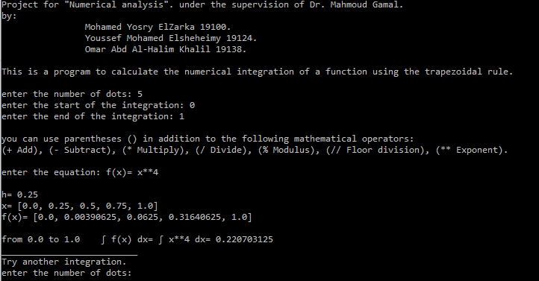**The program**

**Source code in C++:-**

1 #include<iostream>

2 #include<iomanip>

3 #include<fstream>

4

5 **using namespace std**;

6 **int** main()

7 {

8 **cout**<<"Project for 'Numerical Analysis' under the supervision of Dr. Mahmoud Gamal."<<**endl**;

9 **cout**<<"by:\n\t\tMohamed Yosry ElZarka 19100.\n\t\tYoussef Mohamed ElSheheimy 19124.\n\t\tOmar Abd Al-Halim Khalil 19138.\n";

10

11 **fstream** Xline, Yline;

12 Yline.open("Y.txt", ios::app);

13 Xline.open("X.txt", ios::app);

14

15 **double** x[1000] = { 0 }, fx[1000] = { 0 }, h = 0, res = 0;

16 **int** n;

17 **cout**<<"This is a program to calculate the numerical integration of a function using the trapezoidal rule.\n";

18

19 **cout** << "Enter The Number of dots(n) : ";

20 **cin** >> n;

21

22 **for** (**int** i = 0; i < n; i++)

23 {

24 **cout** << "Enter value of x = ";

25 **cin** >> x[i];

26 Xline << x[i] << ",";

27 **cout** << "Enter value of F(x) at x of "<<x[i]<<" = ";

28 **cin** >> fx[i];

29 Yline << fx[i] << ",";

30 res += fx[i];

31 **if** (i)h += x[i] - x[i - 1];

32 }

33

34 h /= n - 1;

35

36 res -= fx[0] * 0.5;

37 res -= fx[n - 1] * 0.5;

38

39 **ofstream** out ("X.txt");

40 **ofstream** out1 ("Y.txt");

41

42

43 **for**(**int** i=0;i<n+1;i++)

44 **cout**<<"-----------";

45 **cout**<<**endl**;

46 **cout**<<**setw**(10)<<left<<"x"<<"|";

47 **int** counter=0;

48 **for**(counter =0 ; counter < n ; counter++)

49 {

50 out<<x[counter];

51 **cout**<<**setw**(10)<<left<<x[counter]<<"|";

52 }

53 **cout**<<**endl**;

54 **for**(**int** i=0;i<n+1;i++)

55 **cout**<<"-----------";

56 **cout**<<**endl**;

57 **cout**<<**setw**(10)<<left<<"F(x)"<<"|";

58 **for**(counter =0 ; counter < n ; counter++)

59 {

60 out1<<fx[counter];

61 **cout**<<**setw**(10)<<left<<fx[counter]<<"|";

62 }

63 **cout**<<**endl**;

64 **for**(**int** i=0;i<n+1;i++)

65 **cout**<<"-----------";

66 **cout**<<**endl**;

67

68 **cout**<< **endl**<<"Trapezoidal Rule sum = " <<res * h;

69 **return** 0;

70 }

**The program in C++:-**

